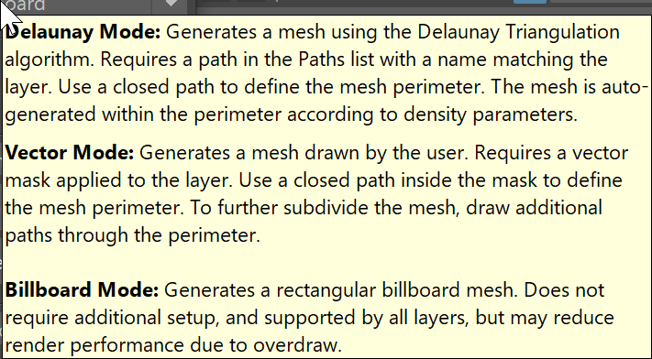
Linear Mode: Generates a mesh with adjustable density using the NURBS Tessellation modifier in Maya. Requires a closed path to define the mesh perimeter, saved in the PSD Paths list, with a name matching the layer name.
Delaunay Mode: Generates a mesh with custom density settings derived from the Delaunay Triangulation algorithm. Requires a closed path saved in PSD’s Paths list with a name matching the layers name to define the mesh perimeter.

Vector Mode: Generates a mesh from custom PSD curves drawn by the user. Requires a closed path, vector mask with additional paths drawn through the perimeter to add vertices to support the desired geometry. Each path intersection will result in one vertex.

Billboard Mode: Generates a rectangular billboard mesh cropped to the alpha of the layer. Does not require additional PSD setup. It is supported by all layers but render performance may be reduced in some engines due to overdraw.

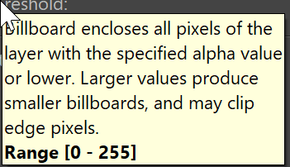
Generated billboard will encapsulate all pixels with the specified alpha value and higher.
Larger values will typically produce smaller billboards because pixels of a lower opacity will be excluded from the mesh boundaries.
0 = Fully Transparent & 255 = Fully Opaque.
Range [0 – 255]

Vector Mode
Merge Vertices:
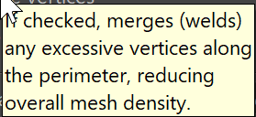
If checked, merges (welds) any vertices within the threshold radius together. Use this to remove excessive vertices where multiple paths intersect.
NOTE to Michaelson: Merge threshold should be invisible, inactive or greyed out until checked.

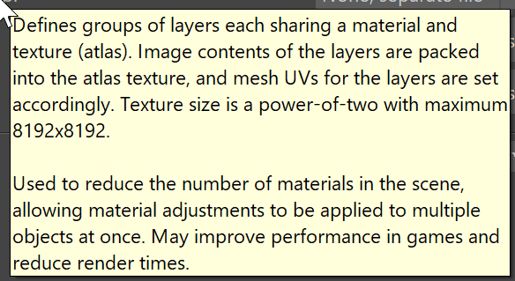
Defines groups of layers to share a material and texture atlas (single uv tile).
PSD layers included in the named group will be organized, using the users preferred packing algorithm, into a single power of two texture atlas with a maximum resolution of 8192x8192. By default, each layer’s resolution will be preserved, so multiple atlas groups may be required for larger layers while groups consisting of small layers may not fully utilize the minimum atlas resolution of 512x512.
Texture Atlas Groups can significantly reduce the number of unique materials generated for a scene allowing material adjustments that affect multiple objects at once. Effective texture atlases may also improve performance in games and reduce render times.

Override default resolution:
When enabled the user can enforce optimal island packing density while setting the texture atlas to a preferred resolution. Please consider your creation platform as game engines will not support non-standard texture sizes.
The Optimal Atlas Resolution shown below refers to the pixel size of the texture atlas when packed with minimal empty spaces.
Layers will be downscaled ##% to fit refers to how much smaller your layers will be made in order to fit snugly and within the desired atlas resolution.
Size Spinner:
Set your custom texture resolution. Game engines will only support standard square texture sizes of 512,1024,2048,4096 and 8192.
Padding:
The number of empty pixels between each UV island. If you are experiences unwanted artifacts on the edges of your geometry, try increasing this value.
Texture Framing
Affects how the specific layers UV’s are generated when not part of an Atlas group. By default textures are Cropped to Layer size making for smaller image files with snug UVs. By setting this option to Full Canvas the layers position and scale in relation to the canvas will be preserved.

Global Parameters
Texture Proxy Size:
Scale all generated textures down by a set amount. This is ideal for faster iteration times without compromising existing Atlas/UV layout.

Layer Window
Mode Selected: The current generation mode chosen for the layer.
Size : The X and Y pixel count of the layer content
Group : The current Atlas group the layer is a member of
Mode Supported: Which geometry generation modes are available for the layer. This depends on additional inputs from the PSD file like associated Paths or Vector Layer Masks.
Export Buttons
Mesh [FBX]:
Generate an FBX containing the meshes of the selected layers. Prompts for file location.
PNG [FBX]:
Export all textures and atlases of the selected layers as PNG. Prompts for folder location.
Mesh+PNG [FBX]:
Generate all outputs for the selected layers, including an FBX contains the meshes and PNGs for textures and atlases. Prompts for file location of the FBX and textures are output to the same folder.

Mesh [Maya]:
Generate the meshes of the selected layers, creating scene nodes and applying materials.
PNG [Maya]:
Export all textures and atlases of the selected layers as PNG, in a folder located under the PSD source.
Mesh+PNG [Maya]:
Generate all outputs for the selected layers, including meshes as scene nodes and PNGs for textures and atlases, placing textures in a folder located under the PSD source.

